Aiken Tier 1B Project Ripple Effect Mapping Session and Community Celebration Report

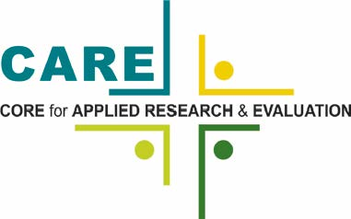

Lauren Workman, PhD, MPH
Maria McClam, MSPH
Arnold School of Public health University of South Carolina
February 2021

Background
In 2015, Fact Forward received a grant from the US DHHS’ Office of Population Affairs to expand the reach of effective teen pregnancy prevention programs. The project, Tier 1B: Expanding the Reach targeted three counties in the state who had teen birth rates that were higher than the national rate: Aiken, Anderson, and Orangeburg Counties. Local implementation in each county was led by a local coordinating agency (LCA). In Aiken, the initiative was led by Helping Hands and their affiliate program, Aiken Youth Empowerment.

Methods
On February 18, 2021, a virtual community feedback session was held to gather perspectives from LCA representatives and other community partners on the impacts of the Tier 1B program. Three (3) participants attended the session; a fourth was unable to participate in the virtual session but participated in a follow up interview to ensure their perspectives were included. The Ripple Effect Mapping (REM) technique was used to guide the session. The REM technique is a participatory method informed by appreciative inquiry (AI) and community coalition action theory that aims to engage community stakeholders in describing the most positive aspects and impacts of the Tier 1B initiative.
Questions designed to elucidate the positive impacts of Tier 1B on the community guided the REM session discussion. Questions included, “What changes resulting from the Tier 1B project are you most proud of?”, “Did anything about the project (e.g. results, actions or efforts linked to the Tier 1B project) surprise you?”, and “Tell me a story about how you have used resources from the Tier 1B project (information, partnerships, etc.).” Answers to questions and discussion points were recorded into a mind mapping software displayed on the screen as participants shared their perspectives. The mind mapping activity continued until no new topics emerged.
Following data collection, the evaluation team reviewed and cleaned up each community map in the mind mapping software (xMind). Mind map nodes were downloaded into Excel and imported into qualitative analysis software. In addition, all sessions were transcribed and analyzed using content and thematic analysis techniques. The evaluation team used an inductive approach to analyze data and identify emergent themes.

Results

Program Successes
Successes of the Tier 1B project in Aiken include the adoption and implementation of an evidence based reproductive health education curriculum, creation of condom access points, dissemination of mass media, and the establishment of a teen friendly health clinic.

Implementation of Evidence Based Reproductive Health Education Curriculum
A key impact resulting from the Tier 1B investment is the successful implementation of evidence based reproductive health education curricula in Aiken County middle and high schools, as well as youth involved in out of home care (including foster care, group homes, and juvenile justice settings). The New Culture curriculum was implemented for middle school aged youth and Making Proud Choices was implemented for high school age youth. A key benefit of the Tier 1B program in Aiken County was that it created a space for consistent implementation of curriculum across the entire school district and community. Thus, students were exposed to standardized messaging and information, regardless of the school they attended within the district. One person said, “we got a curriculum across the board adopted. Prior to the grant we had textbooks approximately 12 years old and no real curriculum to follow. But we adopted [the curricula] and it has pulled us all together…consistently across the district. So, if a student transfers schools within the district, they're still gonna get the same content. 'Cause all of our teachers had the same training and followed the same curriculum.”
Participants explained that the curriculum helped the youth understand and identify characteristics of healthy relationships, which creates a foundation for their lives as adults. One participant noted the specific importance of offering the information in the curriculum to youth in out of home care. Youth in out of home care may be more vulnerable and have the potential to benefit greatly from life skills development, as well as the development of a relationship with a trusted adult for information on reproductive health. The curriculum also taught youth refusal skills that can carry over to avoiding drugs, alcohol, and other substances and other risky behaviors. Moreover, the curriculum built student’s knowledge of mental and emotional health, the impacts of physical relationships on emotional health, and the development of positive self-esteem.
The implementation of the curriculum also established trust between teachers and other facilitators and youth. As a result, participants explained that youth were more likely to come back with questions and open up about other challenges. Again, the importance of having a trusted adult is especially important for out of home youth, as they may move around a lot. One participant explained, “Just knowing that they have that person that they may only see for a week to talk to for that week. They know that somebody knows what I'm going through or I have someone I can talk to about this situation. Because especially when you're in foster care, you may not have that person. Because you're bouncing around so much, it's hard. They really don't trust the system…But having that person to really talk to them about goals and how they see themselves 5, 10, 15 years from now, and how to make their lives better, refusal skills from sex, drugs, whatever, they know they have that person to talk to about those issues.” Participants shared that implementation of the curriculum in schools also supported parents who may be uncomfortable having conversations with their children. The curriculum also had ‘homework’ sessions to encourage youth to discuss lessons with their parents and other trusted adults.
One participant representing the school district shared that the curriculum they selected was a good fit, as it adhered to district and state policies regarding what can and cannot be discussed. For example, information must be shared in the context of ‘future family planning.’ Thus, additional time and effort to greatly modify the curriculum was not needed. This ultimately made it easier for the school district to adopt the curriculum and adhere policies and procedures associated with the SC Comprehensive Health Education Act.

Condom Access Points and Billboards Throughout the County Support Teen Pregnancy Prevention Efforts
Participants also shared how two other key program activities, condom access points and billboards, helped support teen pregnancy prevention efforts. Condom access points are places around the community that youth can get condoms with no questions asked. Locations included barber and beauty shops and other places frequented by teenagers. In addition, the grant supported billboards around the community to advertise 8 free methods of birth control and a website to find more information. According to participants, the billboards provide immediate information, but could also “jump start” conversations between kids and parents. They also noted that the billboards could help reinforce messages that they’ve heard in curriculum lessons at school.

Teen Friendly Health Services
The local Department of Health and Environmental Control (DHEC) clinic was also a key partner in the Tier 1B program. They supported the project by creating teen friendly health services. This included renovating a teen waiting room at the health department. Teens watch the 17 Days video and a take a pre and posttest assessing their knowledge. Tier 1B funds allowed them to make the room more friendly by inserting charging station, providing gift bags for teens, and providing condoms. Someone described the impact of having this space especially for teens: “Going to the doctor as a grownup can be intimidating. So just imagine if you're a 15-year-old.and you go to the health department. You have your trusted adult. They're not judgmental. It's really cute. It's really teen-friendly…it doesn't look like your traditional doctor's office area. And then once you're done – I think you get some type of incentive bag. And you go tell your friends, "You know, I went here and this is what we did and this is what we talked about. It's really nice." And word of mouth just –if I know at 15 I can go here and get what I need and have those conversations, then of course I'm gonna tell my friend when I leave, "You should come here." And just keep spreading it that way.” Participants also noted that because of Tier 1B, staff and providers at the health department have been more open and ready to teach teens and are not shying away from the difficult conversations. Additionally, a participant who works at the health department has noticed a higher case load of teens coming in for visits and watching the 17 Days video after implementation of Tier 1B began.

Community Partnerships Are Essential to Program Success
Participants discussed the importance of partners in the success of the Tier 1B project. They explained that their partners have been reliable, consistent, and responsive to requests for help. For example, one school district representative shared, “Tiiu has continuously offered to come into classrooms for any lesson that a teacher might be uncomfortable with delivering. So, we appreciate that. If you read the state law down to the bottom, it says any teacher who refuses to teach these lessons can be terminated. So, a teacher who might feel strongly about not teaching now has an out and can still not lose their job and have that support from Tiiu delivering the same information.” Participants reflected that the grant has allowed them to build long lasting, positive partnerships and they intend to maintain their collaboration. This support and partnership "makes you want to keep trying…and shows they're just as invested in the youth in Aiken County as we are.”
While teachers did not participate in the feedback session, they were discussed as a key part of the success of the Tier 1B project. Participants explained that they were grateful for the teachers and appreciated their work. During the project, partners worked to show their appreciation to teachers by treating them to lunch during teen pregnancy prevention month. These activities have created a community of support amongst teachers and partners, wherein they feel that they can reach out to one another to facilitate implementation.
The Aiken community also assembled two advisory groups to ensure the project remained relevant and supported continuous improvement. They developed a Youth Action Board, as well as a Community Advisory Group. These groups also had collective meetings to create a space for dialogue between older adults and youth. For example, topics of conversation in these joint meetings included areas for improvement and student perspectives on how the program worked in their local school. Participants indicated that the Community Advisory Group strengthened existing relationships but also created new partnerships among agencies and organizations.

Support, Including Training and Technical Assistance, from Fact Forward Facilitated Quality Implementation in Local Community Agencies
The Aiken team received support from Fact Forward in selecting the curricula that they would implement. Participants shared that they appreciated this support, as it guided them to choose those that were the best fit for their community and school district.
Participants remarked that Fact Forward required a significant amount of training prior to implementation of the Tier 1B project. They were trained on the selected curricula, as well as general information on reproductive health, trauma informed care, and LGBTQ sensitivity. This helped establish a baseline knowledge of reproductive health issues and prepared teachers for quality implementation of the curriculum. The training also included ‘teach backs’, which provided participants an opportunity to test out tougher aspects of the curriculum and increase their comfort level in discussing difficult topics. One person shared how this was helpful: “It gives you that experience on how to teach back some of the tougher units within the curriculum, questions that a student may come up with, how to answer it so that you feel kinda comfortable with it, especially if this is your first time, you're fresh out of college, you don't have any real life experience. So just having that during the training can kind of prepare you. And I've been in different trainings with trauma-informed and the LGBTQ, that population. But applying it to reproductive health and making sure you cover what you need to cover without I guess hurting anyone's feelings, or just making sure you're doing it correctly, was a bonus for me. Because, this was all new to me when I started. 'Cause you have to be mindful, especially in the school setting, of how you answer those questions.”
While there was transition in the Fact Forward team during the grant cycle, participants shared that the staff were supportive and could be depended on to answer questions or provide help. Moreover, when challenges were faced, participants shared that the Fact Forward team provided needed flexibility. For example, when a reporting deadline was too tight for teachers, Fact Forward staff extended the timeline to provide more time to account for their busy schedules. Participants did share that they could have used more training on documenting attendance in schools, but that those logistics were worked out over time.

Sustaining the Progress
The Aiken community is actively sustaining the work of the Tier 1B project. Participants discussed how they are maintaining the investment in their community by continuing to implement the curriculum for youth in school and out of home settings. Since most staff were trained during the grant period, they are ‘up to date’ and can continue implementation as usual. In addition, the team has a plan to train new teachers and other community educators when they come on board. Moreover, they shared that they had used their funds to plan for the future, including purchasing equipment for future use. Importantly, partnerships will continue, as well. One person shared, ““Even though the grant ended last year, I'm still going out – if they call me, "Can you do this lesson?" "Okay, I'm there." Just to know that they still have support locally. Questions I'll answer to the best of my ability. If I don't know of course I have to filter it up. But just knowing that they still have that support. Even after the grant is over.”
In the final year of the project the Fact Forward team and some consultants helped the Aiken team develop a sustainability plan. This plan was shared with school district administration to show the impact of the program (including associated data), as well as to communicate plans to continue the initiative. Participants shared that the Tier 1B project “provided a good baseline for future projects” and set them up for successful implementation of additional reproductive health and youth empowerment programs.

Conclusions
Successes of the Tier 1B project in Aiken included the adoption and implementation of an evidence based reproductive health education curricula in Aiken County middle and high schools, as well as youth involved in out of home care (including foster care, group homes, and juvenile justice settings). This allowed for a healthy dialogue and trust between educators and teens. In addition, the Tier 1B project team initiated the installation of condom access points and billboards across the community. The local health department also enhanced their services to be a more teen friendly environment and to expose teens to reproductive and sexual health education. Participants shared that the Tier 1B project helped strengthen existing community partnerships and created new relationships between organizations and agencies with the shared goal of reducing teen pregnancies. Participants shared that Fact Forward was supportive, flexible, and played an integral role in their accomplishments. In the final year of the project the Fact Forward team and some consultants helped the Aiken team develop a sustainability plan which participants said set them up for continued success in promoting reproductive health education and youth empowerment.

Appendix 1: Map
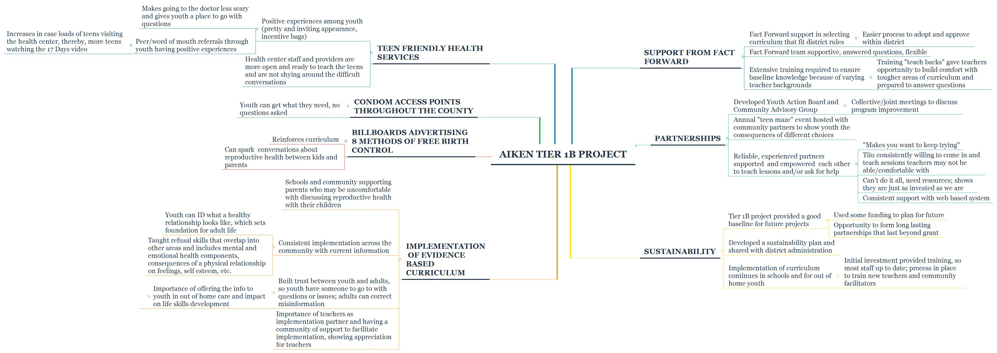

Kollock, Debra Hansen, et al. "Ripple Effect Mapping: A" Radiant" Way to Capture Program Impacts." Journal of Extension 50.5 (2012): n5.
Watkins, J. M., & Cooperrider, D. (2000). Appreciative inquiry: A transformative paradigm. OD PRACTITIONER, 32(1), 6-12.
Butterfoss, F. & Kegler, M. (2002). Toward a comprehensive understanding of community coalitions: Moving from practice to theory. In Emerging theories in health promotion practice and research. R. DiClemente, R. Crosby, & M. Kegler (Eds.) (pp. 157-193). San Francisco: Jossey-Bass.

